**Tejus facility Management Services**

**We Care Your Health & Wellbeing First.**

##### To,

**Sir/Madam**

##### Date:17 /04/2015

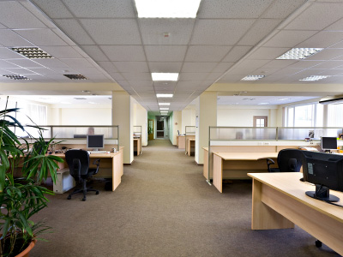

**Entrance/Lobby:** Empty & clean waste receptacles. Clean metal hardware and polish if needed. Clean glass entrance doors inside and out. Clean and disinfect reception area. Pick up and arrange any reading material in lobby.  
  
**Offices/Workstations:** Empty and clean waste receptacles and change liners. Vacuum areas, Sweep and/or dust mop office floors. Clean and disinfect chairs, desks, tables, filing cabinets and other furniture, Disinfect telephones, Clean and disinfect office machines, Dust high ledges, partitions, moldings and other flat surfaces, Rearrange furniture to original order.  
  
**Rest Rooms:** Clean and disinfect fixtures and chrome fittings. Clean, disinfect and refill dispensers from stock. Clean and disinfect toilet seats and undersides. Spot wash walls, partitions and doors. Clean mirrors and polish hardware. Clean and disinfect floors.  
  
**Lunch/Break Rooms:** Clean and disinfect counter tops. Wash appliances, coffee pots, teapots, toaster, and refrigerator as needed, clean and disinfect floors.  
  
**Hallways & Public Areas:** Clean and disinfect drinking fountains. Dust and/or sweep stairs, landings and handrails. Vacuum air grills. Vacuum carpeted areas.  
Optional Available Services:  
**Floor Waxing:** **Stripping, reapplying and sealing of commercial flooring services**.  
**Window Cleaning:** **Clean windows and sills inside and out.**  
**Garages & Sidewalks**: Pick up trash daily. Sweep and hose down debris. Pressure washing is also available.  
**Carpet Cleaning:** Carpet shampoo available upon request.

**Hospitality**

**Housekeeping services**

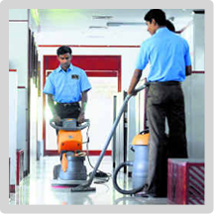

Housekeeping services division is responsible for the upkeep of offices, hospitals, pubs, hotels, Cineplex’s, it parks, airports, libraries and industrial units. Services rendered include daily cleaning, vacuuming, trash removal, floor care, restroom cleaning and interior glass cleaning of the premises.The company offers a one-stop solution to all housekeeping needs. Our trained manpower with sophisticated equipment consistently delivers way ahead ofour client’s expectations.

**One Time Services**

We are counted amongst the foremost service providers regarding onetime cleaning. Our offered service is highly reliable in nature and performed within the given deadline. Onetime cleaning is an area, where our professionals have expertise to offer supreme quality service to satisfy the customers. We have been hired by various reputed clients,

**Sub; Supplying of Looppile carpet .**

**We acknowledge with thanks the receipt of your enquiry seeking our offer for the supply**

**Of loppile carpet. We would like to quote our lowest prices as under along with quality specification and other details etc.**

|  |  |  |  |  |  |  |
| --- | --- | --- | --- | --- | --- | --- |
| **Sl.no** | **Description** | **Unit** | **Rate** | **Amount** | **Vat 14.5%** | **Total Amount** |
| **1.** | **Looppile carpet** | **700 sft** | **52.00** | **36400.00** | **5278.00** | **41678.00** |

**Terms and conditions**

**Delivery after conformation.**

* **Including Laying charge.**
* **Transportation Charge Extra.**
* **Advance 60 %.**

Housekeeping services include :

* Upkeep and maintenance of the premises
* Floor care such as buffing or refinishing
* Window cleaning, wall washing and graffiti removal
* Carpet/upholstery shampooing
* Marble polishing
* Pantry management
* Gardening
* Pest control

**Hope this satisfies your requirement.**

**Our Contact Points are:**

**Service Center No: 8710861566**

**Mobile: 8105852348/9986371198**

**Regards, Srinivas v**

**Bangalore**

**NO 61/38 Ramaiaih Coplex N.T.R Bus stop Bhoopasander**

**Bangalore 560094**